# Drag and Drop

## Lesson 1: Dragging and dropping

Shown below is the HTML code and CSS style that will be used as a base for this lesson

HTML:

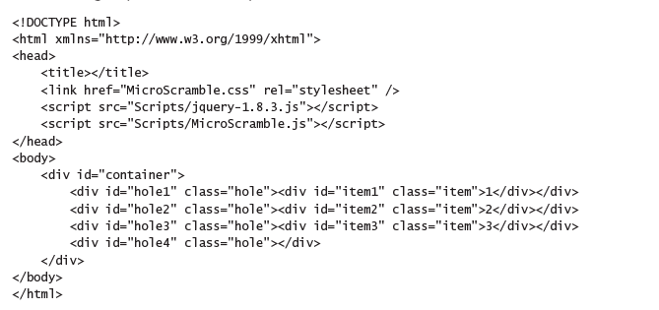

CSS:

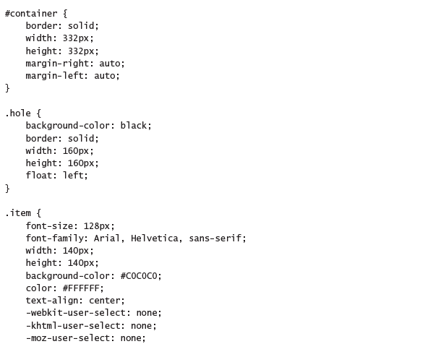

Resulting Page:

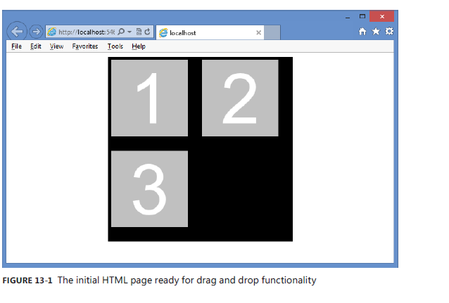

JSFiddle: https://jsfiddle.net/pn5cd92q/ (Trying to drag any element in the JsFiddle doesn't work yet

)

### Dragging

To specify to the browser that an element can be dragged, use the *draggable* attribute, which has three valid values: *true*, *false*, and *auto*.

**Note**: For most browsers, the auto setting is the default, which means that the browser decides whether the element should be draggable.

Modifying the example above gives us the following result

HTML (bolded parts are additions):

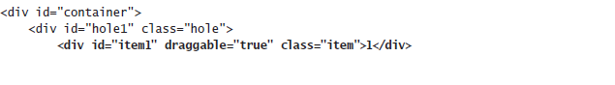 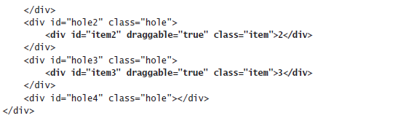

Resulting page:

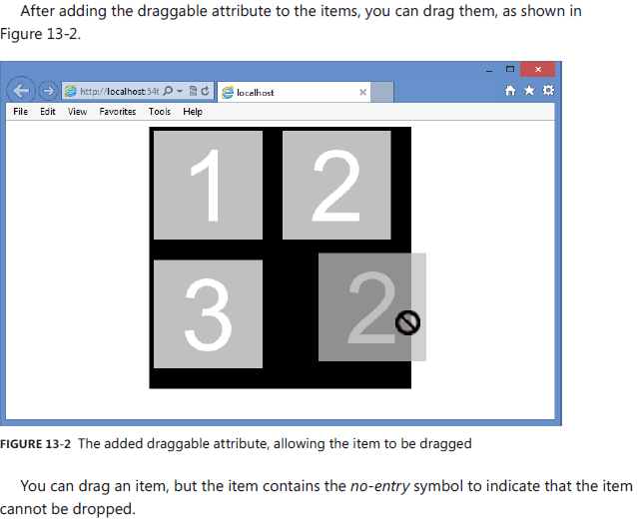

JsFiddle: https://jsfiddle.net/pn5cd92q/1/

### Understanding drag events

When dragging and dropping, there are events that are based on the dragged element(dragstart, drag, dragend), and events that are based on the drop target (dragenter, dragover, dragleave, drop)

### Dragging events

When dragging, the following events are based on the dragged element

* **dragstart** Triggers when the drag is started
* **drag** Triggers continuously as the element is being dragged
* **dragend** Triggers when the drag is finished

The following shows the use of the drag-start and dragend events to change the style of the item being dragged until the dragging ends.

Javascript:

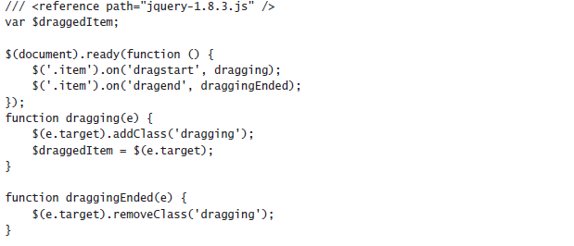

CSS:

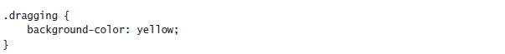

JsFiddle: https://jsfiddle.net/pn5cd92q/2/ (the background of the dragged item changes to yellow until the dragging stops)

### Dropping

After dragging, the drop must be made operational. The following events are based on the drop target.

* **dragenter** Triggers when the drag enters a drop zone
* **dragover** Triggers continuously as the element is dragged over the drop zone
* **dragleave** Triggers when the dragged item leaves a drop zone
* **drop** Triggers when the dragged item is dropped

**Note**: *dragenter* and *dragover* events default to rejecting dragged items, which is why you can’t currently drop an item.

Also note that the *drop event* removes the dropped item from the document object model (DOM) and then adds it back to the DOM at the drop zone location.

The following code subscribes to the dragenter, dragover, and drop events.

Javascript:

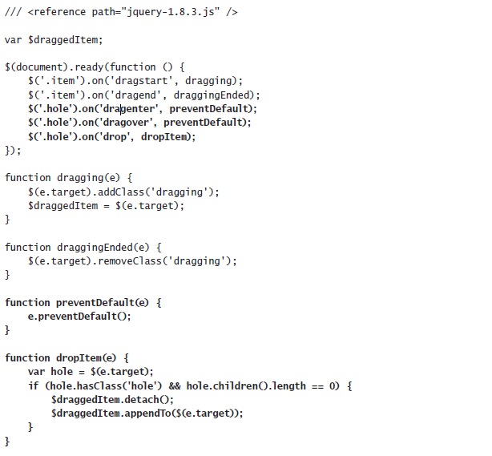

**NOTE**: Notice that *dragenter* and *dragover* call the same *preventDefault* function, which prevents the rejection of the dragged items

Resulting page:

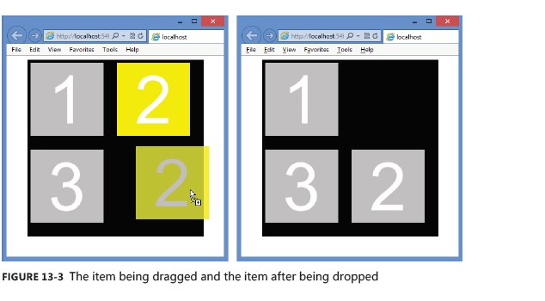

JSFiddle: https://jsfiddle.net/pn5cd92q/3/

### Using the DataTransfer object

We can also use the DataTransfer object to pass data from the dragstart event to the drop event (NO need to create a global variable to reference the item being dragged anymore).

Using the *DataTransfer* object, we can pass any data to the *drop* event as long as it can be represented as a **string** or **URL.**

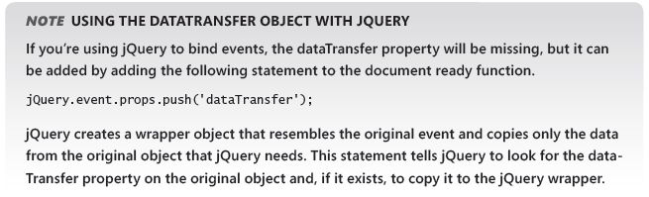

The DataTransfer object has the following members.

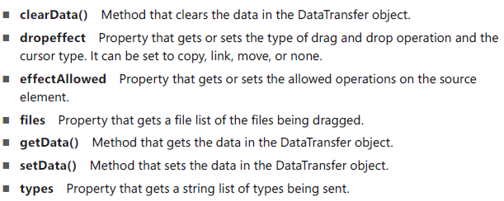

Example below

HTML:

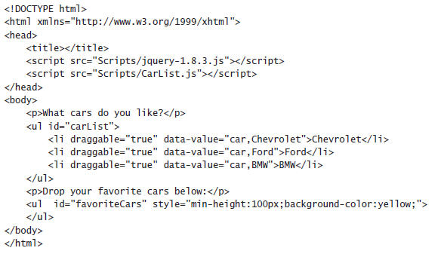

Javascript:

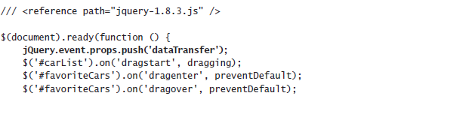

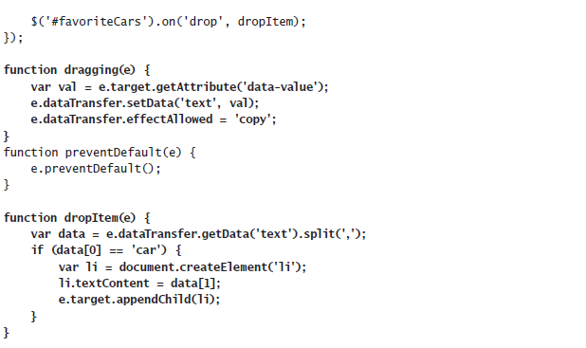

Resulting page:

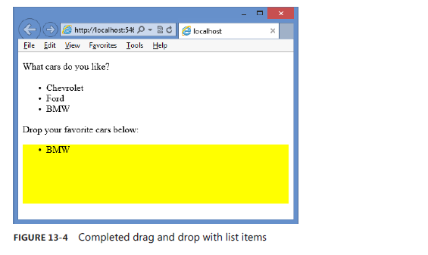

Code explanation:

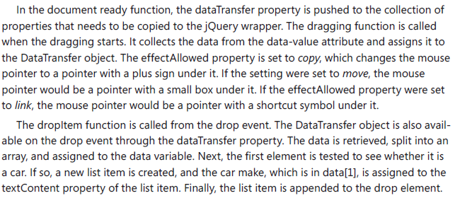

JSFiddle: https://jsfiddle.net/1xq1p372/

## Lesson 2: Dragging and dropping files

You can drag and drop files by using the *File application programming interface* (API), which is also part of HTML5.

### Using the FileList and File objects

When dropping a file, the *DataTransfer* object returns a *FileList* object (a collection of File objects that were dropped).

A File object has the following properties

* **name** Property that gets the file name and extension without a path
* **type** Property that gets the MIME type of the file
* **size** Property that gets the file size in bytes

**Example**: The following HTML document has a <*div*> element onto which files can be dropped and a <*table*> element that is populated with information about the dropped files.

HTML:

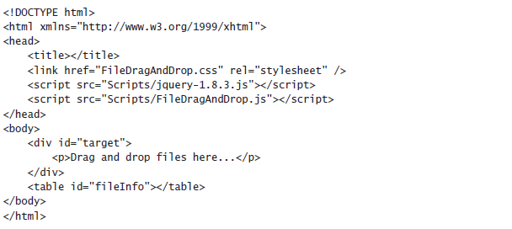

CSS:

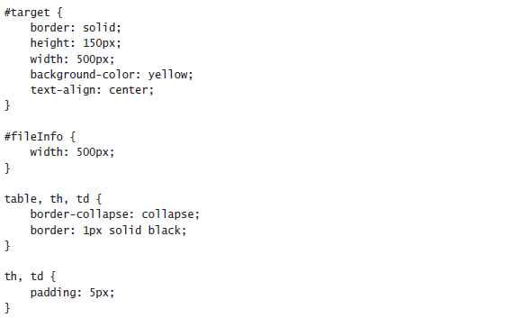

Resulting page:

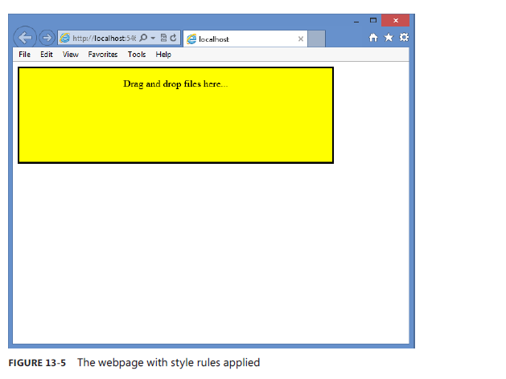

JsFiddle: https://jsfiddle.net/doxm98by/

**Note:** Even with no JavaScript, If you drop a file anywhere on the webpage, the file opens in another window. For example, if you drag and drop a movie onto the webpage, the movie will start playing in a new window

GO TO NEXT PAGE

To process the dropped files and display the file information, look at the code below

Javascript:

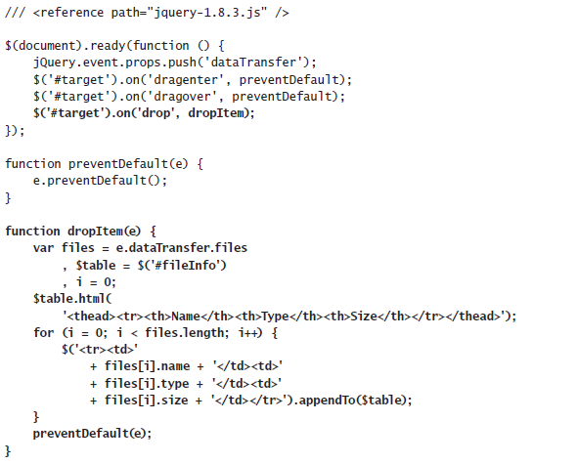

Resulting page:

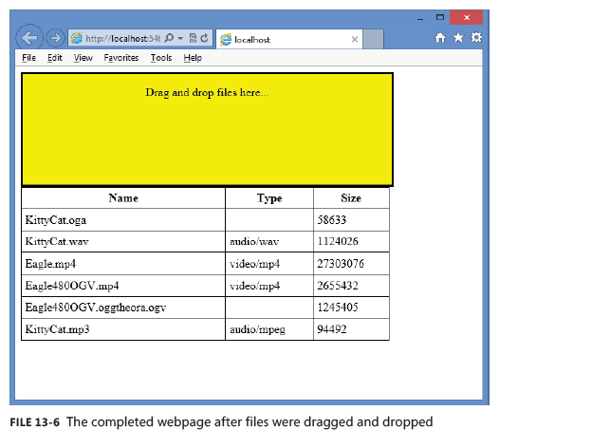  
JSFiddle: https://jsfiddle.net/doxm98by/2/